**CURRICULUM VITAE OF**

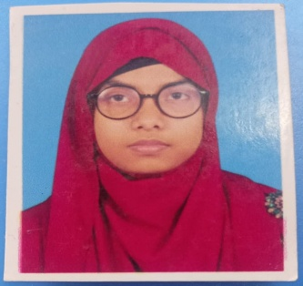

Nazmunnahar Moni

Contact No**: 0156821812**

E-mail: number@gmail.com

**Address: Pirgacha ,Rangpur**

**CAREER OBJECTIVE**

To obtain a position with opportunities to utilize my technical, branding and marketing experiences, skill, talent, creativity, sincerity for the better achievement of the organization.

**SPECIAL QUALIFICATION/EXPERIENCE**

* Professional MS Excel, Word and PowerPoint.

**Ability:**



* Excellent communication skills.
* Self-motivated.
* Hard working.
* Leadership and
* Team collaboration
* Ability to work under pressure.

**EDUCATIONAL QUALIFICATION:**

1. **BACHELOR OF SCIENCE (Honors)**

University : Begum Rokeya University, Rangpur

Department: Physics

Passing Year: 2025

Result: 3.70

1. **HIGHER SECONDARY CERTIFICATE (H.S.C)**

|  |  |  |
| --- | --- | --- |
| Institute | : Lions School and college, Rangpur | |
| Group | : Science | |
| Board | : Dinajpur | |
| Passing Year | : | 2018 |
| Result | : | 5.00 (Out of 5) |

1. **SECONDARY SCHOOL CERTIFICATE (S.S.C)**

Institute

Group

Board

Passing Year

Result

: Kasia Bari BL High School

: Science

:Dinajpur

:2016

: 4.67 (Out of 5)



**PERSONAL INFORMATION:**

**Name**

: Nazmunnahar Moni

**Father’s Name**

:Abdul Baten

**Mother’s Name**

: Morjina Begum

**Sex**

: Female

**Marital Status**

: Single

**Religion**

: Islam

**Nationality**

: Bangladeshi (By birth)

**Date of Birth**

: 15 May, 2000

**Blood Group**

: A+



**Work Experience**



**International Trade Fair 2023**

|  |  |  |
| --- | --- | --- |
|  | Job Title | : Sales Representative |
|  | Company Name | : RFL(Best Buy) |
|  | Location | : Purbachal |
|  | Private tutor( self employed) 2018 to present | : Physics,Mathematics,ICT and English at Rangpur. |
|  | **Interest** | :Travelling, listening music, watching English movies and reading books. |
|  |  |  |

**and correct to the best of my knowledge and behalf.**

